First Circular

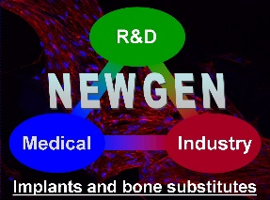

Tomas Bata University in Zlin, Czech Republic
is pleased to invite you to attend

The COST Action MP1301 NEWGEN

New Generation Biomimetic and Customized Implants for Bone Engineering

Workshop / WG Meeting

Topic: Hydrogel / Biomineralized Biomaterial for Bone Tissue Regeneration
(for invited, oral & poster presentations)

Dates: November 15th-16th, 2016

Venue: Centre of Polymer Systems (U17)
Třída T. Bati 5678, 76001 Zlín, Czech Republic

Registration deadline: October 22nd, 2016

Contacts: Local Organisers: Nibedita Saha - nibedita@uni.utb.cz
Monika Kasálková - kasalkova@rektorat.utb.cz
NEWGEN : Véronique Huart – mp1301 @bcrc.be

For further instructions and information please see NEWGEN and TBU web pages: www.cost-newgen.org /www.utb.cz

Accommodation Information in Zlin:
Hotel Baltaci Atrium***** (http://www.baltaci.cz/?lang=en )
Lesní Hotel **** (http://www.lesni-hotel.cz/?lang=2 )
Hotel Tomášov**** (http://www.hotel-tomasov.cz/en/ )
Hotel Baltaci u Nahonu*** (http://www.zlinhotel.cz/en/ )
Hotel Ondráš*** (http://www.hotel-ondras.cz/en/ )
Hotel Saloon (http://www.hotelsaloon.cz/hotel.html

Tomas Bata University Location Map link: http://www.utb.cz/structure/location-map?lang=2

Registration form

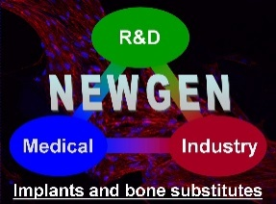

COST Action MP1301 NEWGEN Workshop/WG Meeting

in Tomas Bata University in Zlin, Czech Republic

November 15th-16th, 2016

Registration form

Name :
Affiliation :
Address :
Postcode : |  | City :
E-mail : | @

I wish to attend the NEWGEN Workshop/WG meeting organized in Zlin
even if I am not partially/fully reimbursed by the COST action MP1301 NEWGEN
except if I am not partially/fully reimbursed by the COST action MP1301 NEWGEN

I wish to present a contribution:
Oral
Poster

Title :

Authors:

To be returned before October 22nd 2016

by e-mail to Véronique Huart : mp1301@bcrc.be

Guidelines to reach TBU Zlin
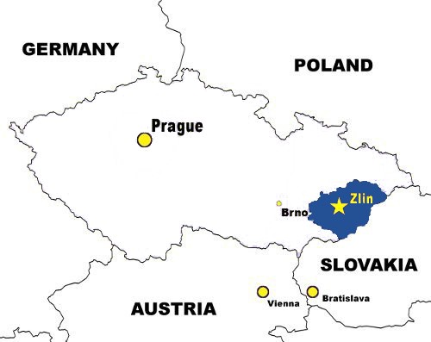

How to reach Zlín?

Step I

Take flight to Prague / Bratislava or Vienna from where there are many trains connecting these cities (Prague / Bratislava / Vienna) and Otrokovice (train station 10km from Zlín center)
Please see the link: http://jizdnirady.idnes.cz/vlakyautobusy/spojeni/
Here, you can find your journey schedule from Prague / Bratislava or Vienna to Otrokovice

From “Prague Airport” to “Praha Main Train Station”, there is Airport Express Bus (AE)
http://czech-transport.com/index.php?id=357

From “Vienna Airport” to “Vienna Main train Station”
http://www.viennaairport.com/en/passengers/arrival parking/s-bahn suburban_railway

From “Bratislava Airport” to “Bratislava Main train Station”
https://bratislava-slovakia.eu/places/bratislava-airport

Step II

Train or Trolleybus connections to reach Zlín center

The best option is to take train from Prague, Bratislava or Vienna to reach Otrokovice, from where there are frequent (every 5-10 minutes) trolleybus connections to Zlín center. There is also connecting train from Otrokovice to Zlín going almost every hour. There are train connections from Otrokovice to Prague, Brno, Olomouc, Ostrava every 2-3 hours/vice versa, and few direct trains to Vienna, Bratislava, Budapest and Warszawa per day. All these connections are provided by Český dráhy.

It is possible to buy all inland train tickets online: https://www.cd.cz/eshop/default.aspx

Alternative option, for travelers from Prague is to take luxury train of company “Student Agency” till Olomouc and then change to the bus from Olomouc to Zlín. Price of this connection is almost the same as for trains of state owned company Český dráhy, however you get free coffee in the train and bus + there is WiFi connection. It is possible to buy joined ticket for bus+train connection of this company both in the offices of Student Agency or online. https://jizdenky.regiojet.cz/?0&wicket:interface=:0:1

There are no international buses, stopping in Zlín. If you want to get to Zlín from some other Czech city where, train connection is not very convenient, you can search for connection and buy the bus ticket online.
Further, you can search connections within Zlín and Otrokovice or vice versa from this link: http://jizdnirady.idnes.cz/zlin/spojeni
Bus stop located next to Otrokovice train station is called "Otrokovice,žel.st.", main stop in the city center is "Nám.Práce"

ROAD MAP to reach ZLIN from PRAGUE / PRAHA

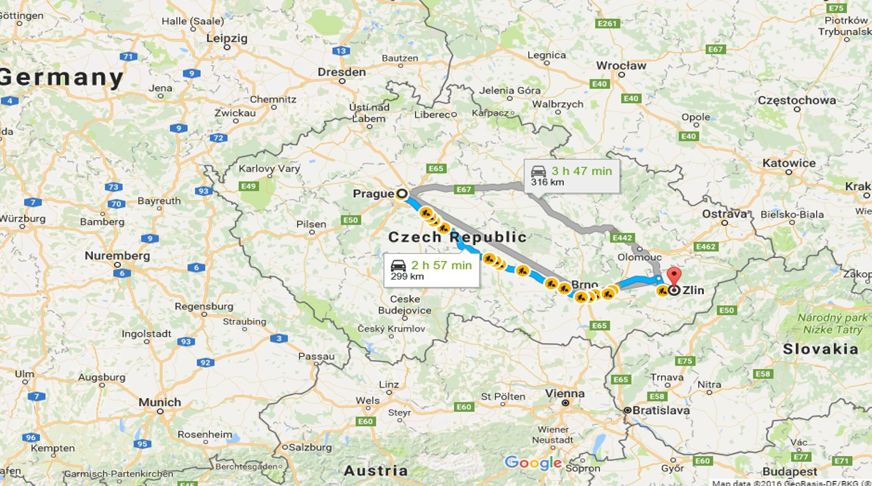

LOCATION of WORKSHOP/WG Meeting BUILDING (U17)

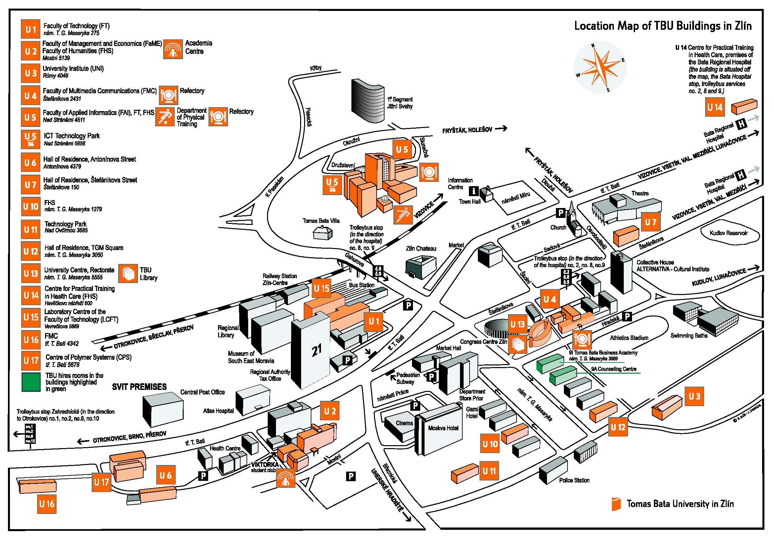
WORKSHOP/ WG Meeting Place (U17)

